General

- Registration is free.
- To attend in our virtual meeting with or without poster, registration is required.
- The event is a virtual conference.
- The decision about your submitted abstract will be informed in the event webpage.
- Please use your academic email address for registration, preferentially.
- The accepted abstract will be published in Biomacromolecular Journal (BMMJ; ISSN:7280-2423).
- For help, please call +982433153339.
- Registration is extended by Jan. 26, 2021.
- Please prepare your poster in English and PDF format. Please ready to present your poster at assigned time.

Attendance in virtual events (lecture/poster)

- It is required to create an account, sign up, in our system to attend in virtual meeting or poster session. IASBS members do not need to create a new account.
- To create virtual meeting account please follow this link: https://conf.iasbs.ac.ir
- In registration step, you provided us your full name and email. Please use same full name and email in sign up step, preferentially:

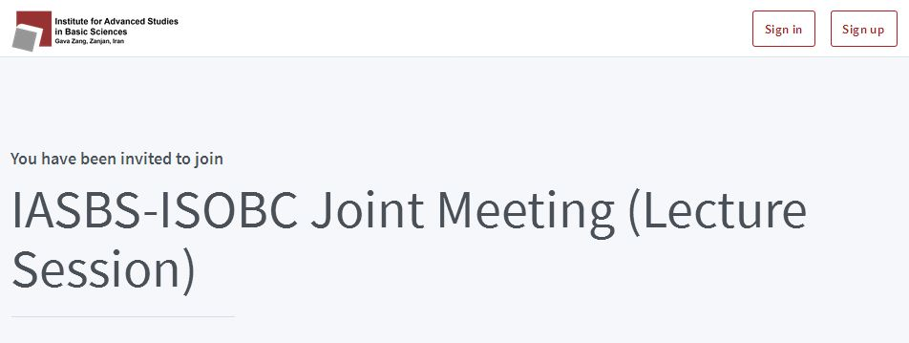

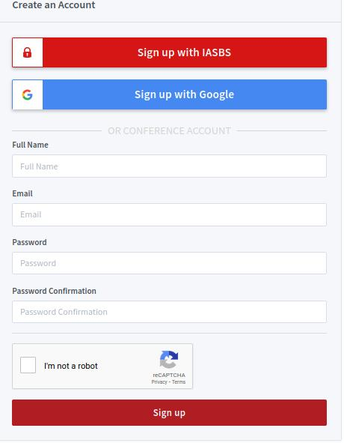

- You may also signup using your Google account.
- Your account will be approved by admin. After approval, you will be permitted to attend in lecture and poster sessions. Admin will provide you appropriate accessibilities.
- Before sign in, please read carefully these helpful links: Help and FAQ. The mentioned links help you to find our virtual system capabilities.
- To attend in meetings or view posters, please sign in using following “Sign in” menu by providing your account information:

