General comments

- The decision about your submitted abstract will be informed in the event webpage.
- Please use your academic email address for registration, preferentially.
- For help, please call +982433153339.
- Please prepare your poster in English and PDF format. Please ready to present your poster at the assigned time. One of the poster’s authors is required to present the accepted poster, in person.
- If you have registered to attend with poster presentation, please wait to receive the acceptance letter before pay the fees.
- If you have registered to attend with no poster presentation, please pay the fees by February 10, 2024.
- The accepted abstracts will be published in Biomacromolecular Journal (BMMJ; ISSN:7280-2423). The Journal is indexed in Google Scholar, Scientific Information Database (SID) and Islamic World Science Citation Center (ISC).

Attendance in virtual events (lecture/poster)

- It is required to create an account, sign up, in our system to attend in virtual meeting or poster session. IASBS members do not need to create a new account.
- To create virtual meeting account please follow this link: https://conf.iasbs.ac.ir
- In registration step, you provided us your full name and email. Please use same full name and email in sign up step, preferentially:

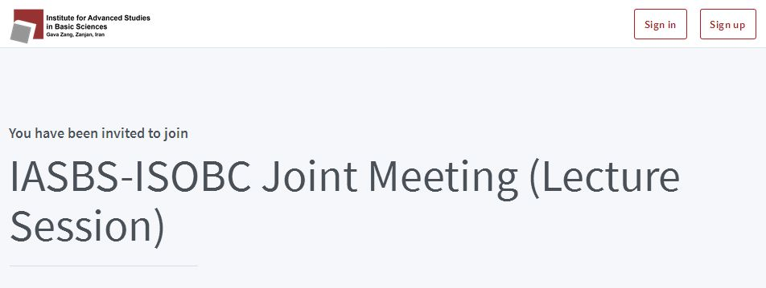

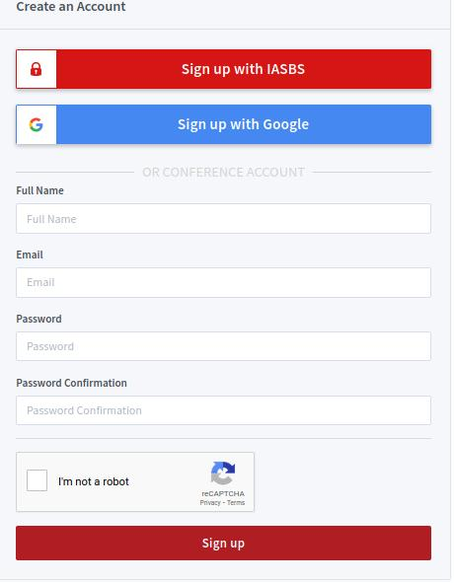

- You may also signup using your Google account.
- Your account will be approved by admin. After approval, you will be permitted to attend in lecture and poster sessions. Admin will provide you appropriate accessibilities.
- Before sign in, please read carefully these helpful links: Help and FAQ. The mentioned links help you to find our virtual system capabilities.
- To attend in meetings or view posters, please sign in using following “Sign in” menu by providing your account information:

